Resource Disclaimer
This resource was developed to support learning for remote mode students normally enrolled in distance education.

Resources are updated by the teacher to ensure currency and are not designed to be stand alone, but integrated into a blended learning environment where students’ learning is supported with a range of peer to peer and teacher to student interactions. These can include interactive and collaborative technologies as well as a range of traditional communication methods such as email, phone and learning management processes.

This resource may contain distance education specific content / instructions and should be adapted and differentiated by the class teacher before distributing to meet the needs of their students and recognise their students’ context.

These documents have been harvested from distance education resources on March 12, 2020 to support all teachers in providing a continuity of learning for their students in the event of student absence during this difficult time.

The following copyright statement supersedes any reference in this document to the Part VB of the Copyright Act 1960:

Some of this material may have been copied and communicated to you in accordance with the statutory licence in section 113P of the Copyright Act. Any further reproduction or communication of this material by you may be the subject of copyright protection under the Act. Do not remove this notice. 24/03/2020

Updated – 24 March 2020

Maths Life Skills
adding shopping items

First name:

Last name:

colour the day

Monday Tuesday Wednesday

Thursday Friday Saturday Sunday

Add these items to find the total.

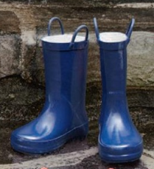 | 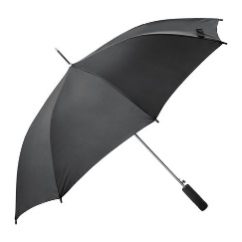 | 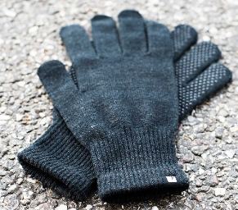
$11.50 | $14.00 | $5.00

Total: $ ________________________

Circle the coins or notes you would use to pay for the items.
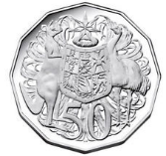
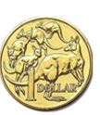
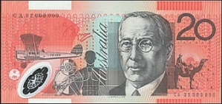
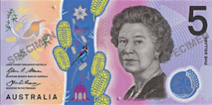
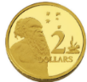
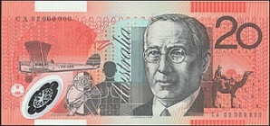

Add these items to find the total.

 | 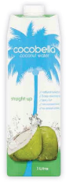
$6.50 | $5.00 | $8.00

Total: $ ________________________

Circle the coins or notes you would use to pay for the items.

Add these items to find the total.

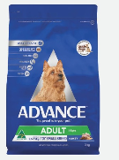 | 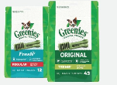
$11.00 | $7.50 | $3.00

Total: $ ________________________

Circle the coins or notes you would use to pay for the items.

Add these items to find the total.

$4.00 | $6.00 | $2.50

Total: $ ________________________

Circle the coins or notes you would use to pay for the items.

